Mahara
http://myportfolio.aut.ac.nz/mahara/

What can lecturers use Mahara for?
Mahara is an electronic portfolio or ePortfolio. The simplest starting point is to consider an ePortfolio as an extension of the paper based-portfolio, bringing with it the obvious benefit of making a portfolio of evidence portable and shareable anywhere that you have Internet access – "the new generation of the three ring binder" JISC My World Project Final Report, Roberts. 2006
In fact, an ePortfolio has a much broader scope as an online collection of reflections and digital artefacts (such as documents, images, blogs, resumés, multimedia, hyperlinks and contact information). Learners and staff can use an ePortfolio to demonstrate their learning, skills and development and record their achievements over time to a selected audience. Mahara.org. 2011
- Pages can be shared by students to showcase their work, used as a form of assessment or reflective practice by using learning journals. Students can have other pages such as a page for friends and family that includes holiday photos and a personal blog. Another page can be created to show examples of best pieces of work and a CV for potential employers
- Lecturers can create sample templates and allow copying (Allowing people to copy a portfolio, Page 3) and share them with a group or an individual.

A quick checklist of steps to follow as a lecturer

- Request your paper to be setup as a group on Mahara. Please send these requests through to Shen Zhang, Lisa Ransom or Nawal Chanane.
- You can either advise students to create their own pages or to copy a template page you have setup. Please see user guide Allowing people to copy a portfolio, Page 3.
- If you wish to provide feedback to students before they submit their page for assessment you need to get them to give you ‘page’ access. The best way to do this is if all tutors in the group need access, is to get the students to add the ‘group’ tutor to have page access. Please see the user guide Adding page access in a group for a tutor, Page 6.
- When students are ready to submit their work they need to submit the ‘page’. This will lock the ‘page’ for editing, enabling you to provide feedback and mark the assessment. You can then release the ‘page’ back to them when you have finished. Please see the user guide
Submitting a portfolio for marking, Page 7.

Please view our Userguides and Videos under the Links and Resources link on the Mahara homepage on how to do the following things:

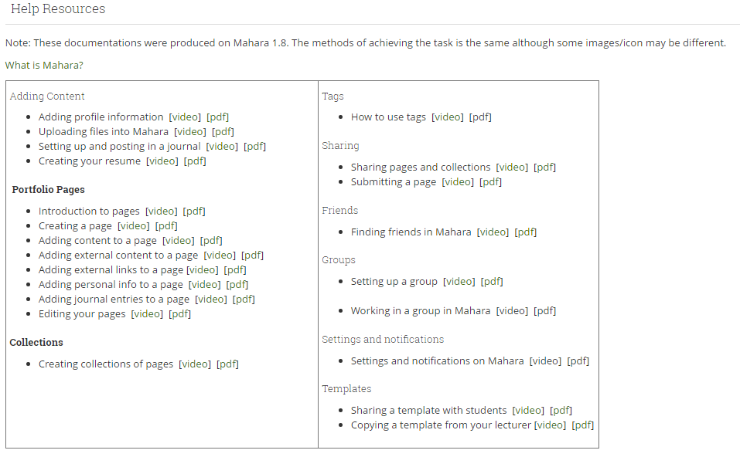

Allowing people to copy a portfolio
Go to Portfolio- Shared by me, and select ‘edit access’
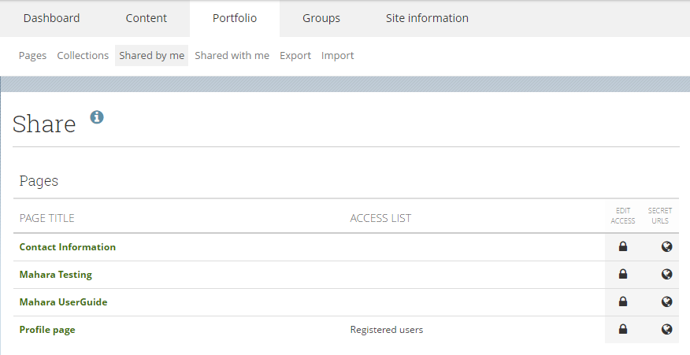
This will bring up a ‘Shared’ area where you can manage any share conditions, by selecting the Pages or Collections you wish to modify.
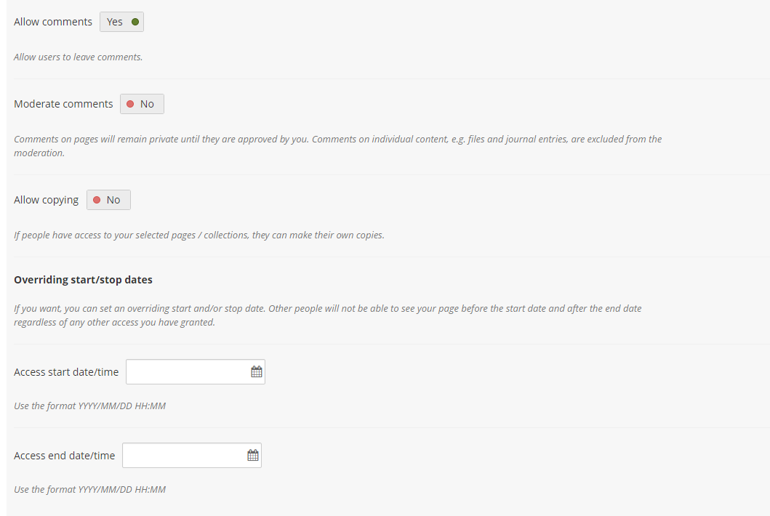
You can search for people you wish to create access for in the search box, under the ‘Share with other user or groups’ option.
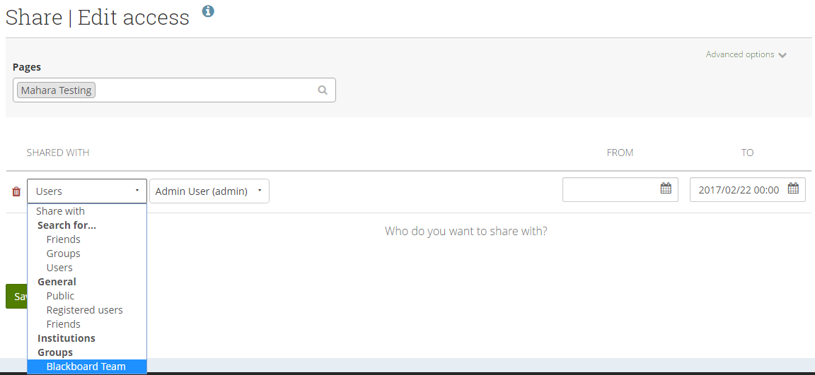
Once you have found the individual, simply click add and then the individual will appear above as added. If you want to allow a ‘group’ to have access select groups instead and search for the group name.

To allow copying not just page access, select ‘Advanced Options’ and tick the ‘Allow copying’ option.
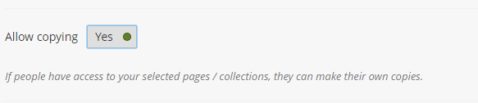

When the student is happy, with the copied page, they can click 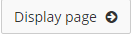 and the copied page will appear under the students list of pages in their portfolio.
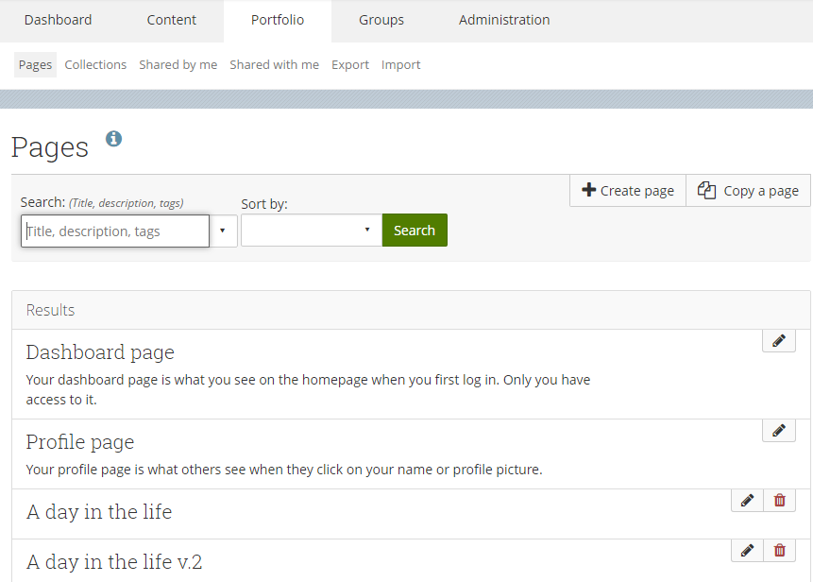

Adding page access in a group for a tutor

An easy way to see ‘pages’ both those shared and submitted is through the Group’s ‘About’ page.

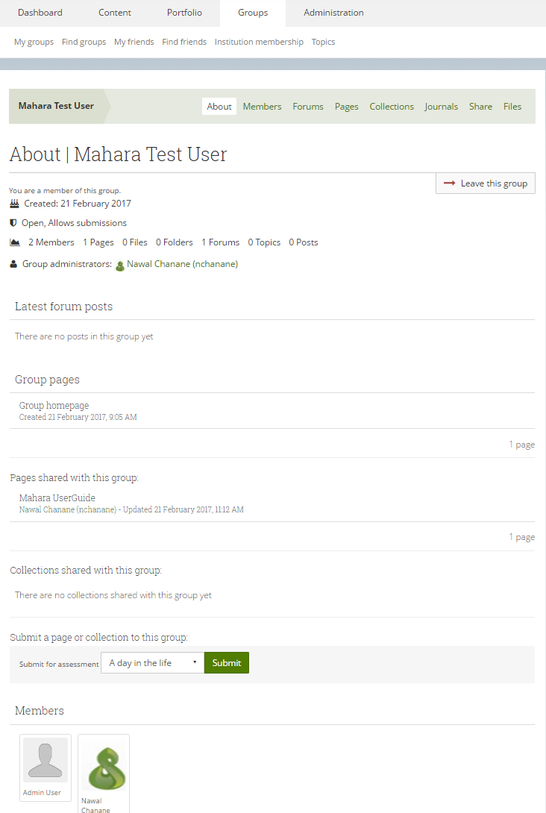
For a student to share their ‘page’ with the ‘group’ tutor, they need to select Tutor after finding the group. This enables easy access to all students ‘pages’ in the group area. Only the tutor has this overall view of the ‘group’ area.
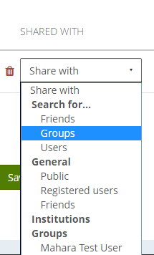
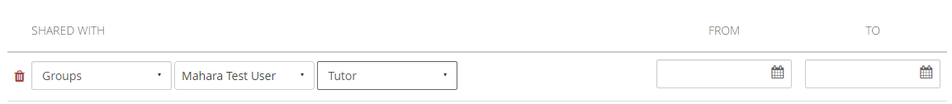
Submitting a portfolio for marking
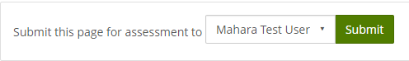
Students can submit their portfolio for assessment by clicking on the 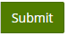 button. Students will receive the below warning before submitting the assessment.
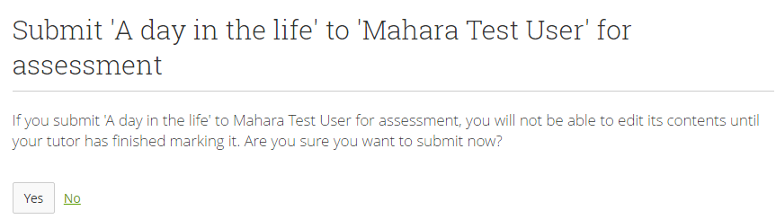
The student will only be able to edit that ‘page’ again when it has been marked and released back to them.
The student’s submitted page for marking will appear under the ‘About’ tab in the group they are in. Only admins or tutors of the group have access to this.
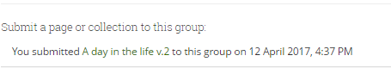

The student’s page can then be released back to them when the marking has been completed.

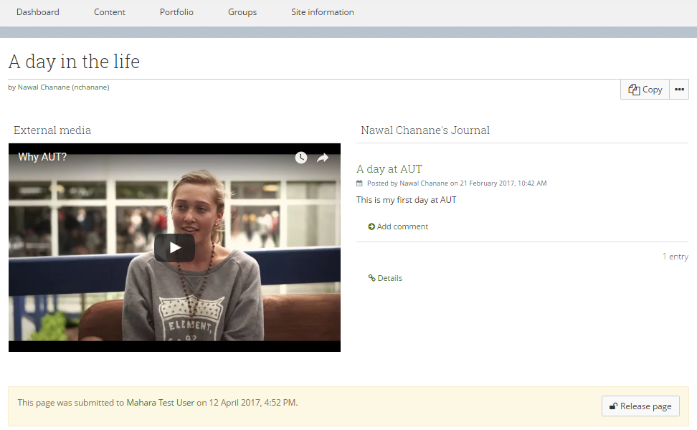

An easier way to manipulation columns when editing a portfolio
Go to Settings. Then set the box to Yes to turn on the controls for adding columns, this is set as off by default.
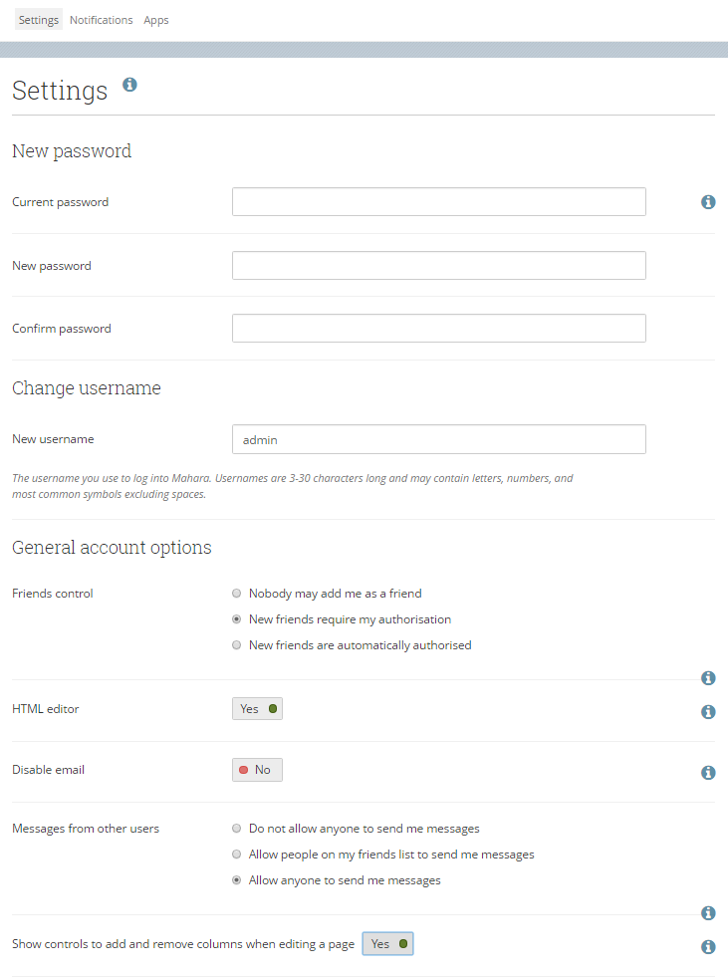
You will now see extra buttons as shown below making adding or removing columns a lot quicker.

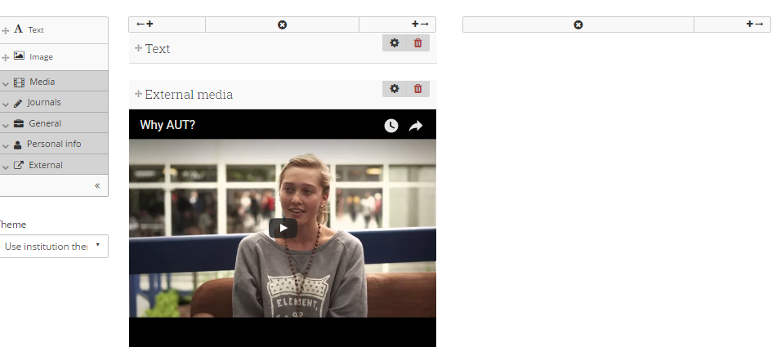
Changing your notification preferences
Go to settings → Notifications
Each of the notifications preferences can changed as shown below:-
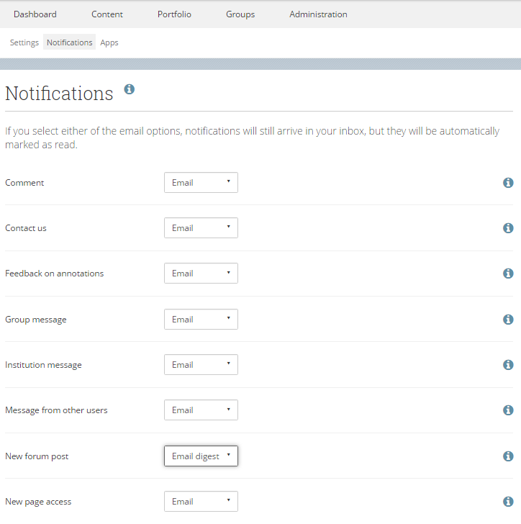
- Email is the default option and you receive an email every time the event listed occurs.
- Email digest will send you all your notifications grouped together every 24 hours.
- Activity log will not send you any emails but you will see notifications under your notifications area.

Note: If you have either email options the notifications you also appear under the notifications area, but they will be marked as read and automatically be removed from your log after 60 days.

